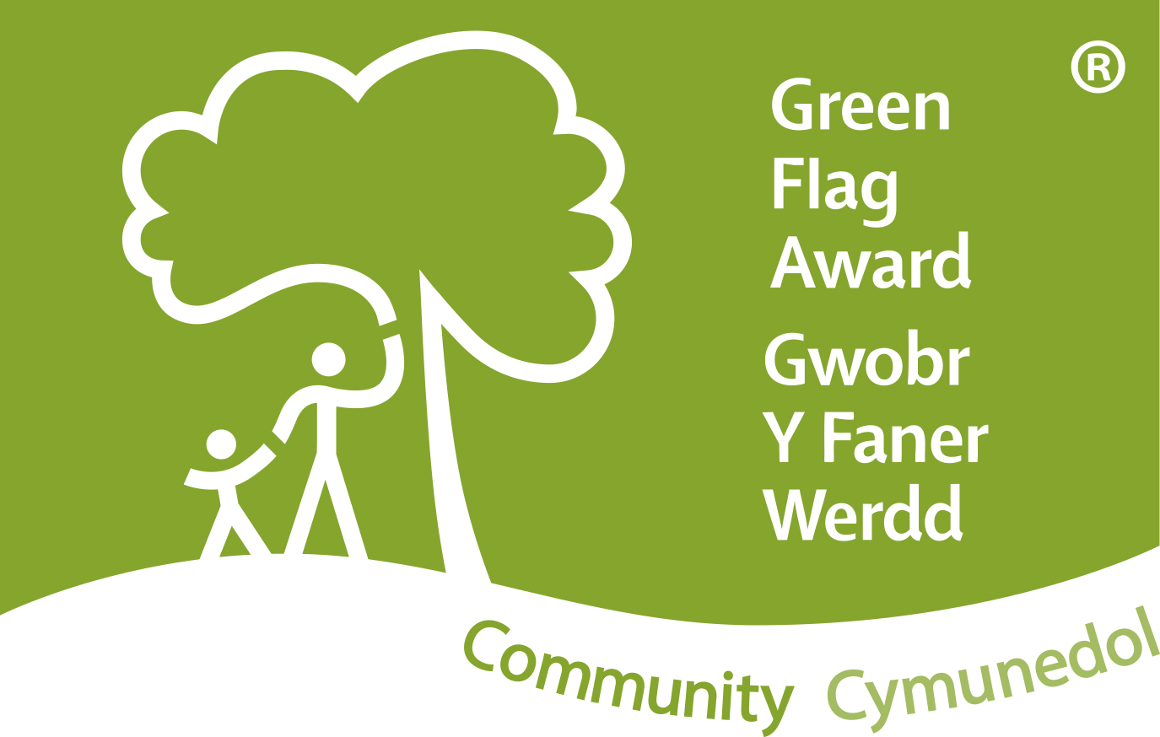
Green Flag Community Award 2016/17

Name of Site: Old Hall Gardens
Name of Community Group: Cowbridge Charter Trust

Band scores | 30-44 | 45-54 | 55-59 | 60-65 | 66-69 | 70-74 | 75-79 | 80+

Status: PASS
Band score:

Field Assessment Feedback

Criteria | Strengths | Recommendations
Welcoming Place

Good and safe access | Excellent access to the garden with clearly defined pathways in keeping with the nature of the site. Access is good for buggies and wheelchairs for the majority of the site.  The rampart walk is not accessible for buggies and wheelchairs due to the nature of the structure.
Welcoming | There is an information board and leaflets in the entrance area accessed from the high street.
Signage | There is no signage from the high street or any signs saying ‘Old Hall Gardens’ from any access point | I would suggest that a finger post is obtained to direct visitors from the high street.  ‘Old Hall Gardens’ signs to be obtained to announce the garden to visitors at all access points.
Equal access for all | With the exception of the rampart walk all the garden is very accessible for all visitors.
Healthy, Safe & Secure

Personal security | The garden is a lovely place to be and feels safe and secure. It is very close to the high street and the library and a private children’s nursery are within the garden site. There are lots of visitors and people walking through the garden.
Safe equipment and facilities | Tools and equipment are stored safely.  Site is checked weekly at the beginning of the volunteer session on Thursdays. Any problems are reported to the Council immediately. The response time to reporting a hazard are prompt.  Risk assessments are reviewed annually by a well qualified member of the trustee board.
There are many distinct natural areas within the garden. A fernery, wildflower meadow, wisteria walk, pond with fish and more.

Excellent opportunities for events, photography and educational visits.
Appropriate level of facilities
Dog fouling | None
Clean & Well maintained

Litter and waste management | None seen when visiting. The site is well cared for. Bins are emptied regularly.
Overall standard of maintenance | Excellent levels of maintenance of this garden are evident with a team of highly skilled and knowledgeable volunteers working hard to sustain and build on the work already completed.
Graffiti and vandalism | None seen on the day of my visit but sometimes one area is used for teenagers to hang out. This area is closely monitored.
Sustainability

Peat use | None
Pesticide use | Minimal
Sustainable materials use | Composting and all plant material and stones are used to create habitat piles for wildlife in cosy damp areas of the gardens.
Waste recycling and minimisation | Nothing is taken from the site and all plant material is recycled and reused.
Conservation & Heritage

Conservation of landscape & historic features | The garden walls have been restored and other areas rebuilt in a sympathetic and appropriate way to conserve the original historic features. The gardens individual areas are quite distinct and this has been built on to create a special feel and look to each part of the garden.
Conservation of biodiversity | Biodiversity and wildlife conservation is at the heart of the gardens. The walls that have been rebuilt have nooks and crannies for wildlife to live. Ivy towers have been created to replace the ivy which was removed when the walls were restored. Any dead standing trees have also been converted to ivy towers.  There are unmown areas in all the parts of the garden which are divided by metal trellis which protects the wilder areas from visitors and mowers. The planting scheme plans are also built around the encouragement of wildlife and pollinators into the areas.
Community Involvement

Promotion of green space / project | The site is well promoted and a range of informative leaflets are available. The nature trail leaflet which is available in the library is a fantastic tool for families to use to explore the gardens.  The interpretation boards are well designed and informative. | It would be good to see the site identified with signage ‘Old Hall Gardens’ to announce where you are about to enter to the visitor.
Links to the wider community | Working with the local beaver scouts on nature related and gardening badges.  Story space created with an award from Biffa in 2009. This is a lovely area for any groups to read and enjoy stories outside.  Cowbridge food festival uses the space for tents and activities.  Churches together – walking nativity in the gardens  Regular public events are held including a moth night  A new dragon garden is being created with the help of the local beaver scout group
Involvement in decision making | A garden is maintained and nurtured by a dedicated and organised group of volunteers.
Involvement in operations | The volunteers worked every Thursday in the garden. All volunteers work together for the benefit of the garden, bringing their own expertise and skill with them to share and develop every aspect of the garden.  All volunteers wear branded polo shirts with pride.
Appropriate provision for the community | The gardens are a perfect addition for the town and the people of Cowbridge. The gardens are a hidden gem of calm and peace in a busy world.
Management / achievements

Innovation and creativity | The story telling area adds an exciting facility to the gardens.  A lovely and informative nature trail has been developed and is available for families.
Resources secured / used | The majority of the funds have come from Creative Rural Communities and Environment Wales. The story space was funded by a £5k Biffa award.
Additional Comments
An amazing garden with so many different areas and features. Signage for the garden and directional signs from the street would ensure visitors are aware of where they are – Old Hall Gardens. I think many people walk through but don’t realise they are in the Gardens.

The volunteers are knowledgeable and passionate about the gardens. They have developed and improved a very interesting and diverse garden. Old Hall Gardens is a very special place to visit and is a wonderful attraction for Cowbridge town.

