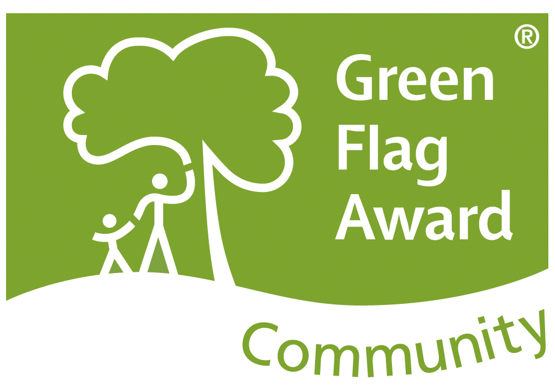

Green Flag Community Award 2017

Name of Site: Old Hall Gardens - Cowbridge
Name of Community Group: Cowbridge Charter Trust

Field Assessment Comments

Criteria | Strengths | Recommendations
A Welcoming Place

Welcoming | Good information board and also leaflets available from the access point at the high street.
Good and safe access | Good, clear access points to the gardens with pathways wide enough for Wheelchair users and pushchairs.  Ramp area walkway not suitable for pushchairs or wheelchairs due to the nature of the pathway and the stairs at the opposite end.
Signage | Signage from the high street into Old Hall Gardens but not from The Physic Gardens. I believe the team are trying to locate a source of funding to help with this | I would be nice to see signage in place from the Physic Garden leading people into neighbouring Old Hall Gardens
Equal access for all | Good access for all visitors (with the exception of the ramp area as discussed previously)
Healthy, Safe & Secure

Appropriate level of facilities and activities | Defined areas within the gardens are pond, Dragon trail, wisteria walk and wildflower area as well as a courtyard that provides welcoming shade and seating area.
Safe equipment and facilities | Equipment is stored securely in a shed. Access is only permitted on Thursdays with the volunteers.  Benches are in good condition and there are some bins available in the courtyard area just off the high street.
Personal security | A wide open space very near to the high street. Feels very safe and a library and a children’s nursery is within the grounds. People using the gardens often on the day of the visit.
Control of Dogs/Dog fouling | None on the day of visit
Well maintained and Clean

Litter and waste management | No litter on the day of visit. Bins dotted around and are emptied regularly.
Overall standard of maintenance | Very high standards of care and maintenance by the volunteers and the garden is a credit to their hard work, dedication and achievements.
Graffiti and vandalism | None seen at time of visit but the area is sometimes used by youths. The volunteers are aware of potential issues and keep a regular check on the area
Environmental Management

Sustainable materials use | Any green waste is turned into compost. The bug hotels are home to minibeasts and bugs and all made from resources and spare bits of materials.
Waste recycling and minimisation | All green waste is composed and recycled.
Chemical Use | Kept to a minimal and only used when absolutely needed
Peat use | None used at this site
Biodiversity Landscape & Heritage

Conservation of landscape & historic features | The Walls have been restored beautifully and conserve the history of the gardens. The look of the garden is kept to reflect the high standards of the team of volunteers.  Period features are in place and well maintained with a fish pond that has received some care and attention
Conservation of biodiversity | Unfortunately, rot was discovered in the Lowsons Cypres tree. Efforts are being made to save as much of the tree as physically possible due to the age and history of the tree. It will be reduced in height but the hope is that one trunk will remain unscathed as it is a key feature in the Gardens.  Bug hotels and Frogs (inc spawn) have made their home in the gardens and the walls have been built with wildlife in their minds. There are wildflower areas protected by a small metal fence to prevent accidental mowing of the area.  The birds observed in the gardens are diverse and it is home to many bees seen on the day.
Community Involvement

Promotion of green space / project | The Gardens are promoted with a very good – up to date website, Nature trail and History workbook & Iolo Trail which is great fun to explore not only the Gardens themselves but also the town and history of Cowbridge.
Links to the wider community | Links to the local Beavers group to create the “Dragon Boarder”. They intend on coming back to do more work and use the work to assist in achieving their gardening badges  Local Library – story space was created by sponsorship of Biffa. The purchase of an all weather awning will help bring the children outside on sunny days and bring the stories to life  Cowbridge Food and Drink festival is held within the grounds each May  National Moth Night where a variety of moths were observed and discussed before being released.  Ron Speed memorial was created to pay respect of one of the residence of the village.  Visit by Sarah Rees and 2 of her sheep for the Welsh Wool Week. They were very special guests and adored by the children  Walking Nativity is a December event and used by the Church  Llanfair Primary School visited the gardens and learned about the history of the gardens and the work being carried out. There is a possibility to develop education visits for the school to aid them with the RHS School Gardening project.
Involvement in decision making | A well organised, skilled and knowledgeable team of volunteers and participate in any projects or tasks needed.
Involvement in operations | Annual visits to other gardens to share projects and ideas are a welcoming fixture and enjoyed by all
Appropriate provision for the community | Gardens are well used by all members of the community and such a beautiful calm and peaceful place so close to the town.
Management / achievements

Innovation and creativity | Story spot with a wonderful backdrop for stories to keep all engaged  Nature trail is a delight and packed full of information, photographs and quiz like tasks
Resources secured / used | Donations received by the public and past projects were funded by Environment Wales in 2014 and Biffa Award.
Additional Comments

I toughly enjoyed my visit with special thanks to Linda and Richard. Such a lovely Garden full of things to see and explore.

Many different and historic features have been sympathetically maintained to a very high standard

A dedicated team of volunteers who’s enthusiasm, dedication and knowledge are very clear to see as well as a passion to bring the community into the gardens.

A beautiful place to visit set in the heart of Cowbridge town centre providing wide array of biodiversity and rich deep history

